Single Equality Scheme:
Foston and Terrington Federation
Updated Sept 2019

Signed __________________________ Date______________
Headteacher

Signed___________________________ Date______________
Chair of Governors

Review due: Report – Autumn Term 2022
Action Plan – Autumn Term 2019

Introduction
This Single Equality Scheme for schools in North Yorkshire provides a format for addressing the statutory duties of the Equality Act 2010 and The Children and Families Act 2014. This supersedes and brings together all previous statutory duties in relation to race, gender and disability and also addresses the duty to promote community cohesion, thus meeting the school’s statutory duties in these areas.
The scheme also highlights how our school has worked with and listened to the staff, pupils, parents and carers to inform development of action plans and the need and commitment required to ensure the scheme is a success. This is underpinned by a commitment to promoting positive relationships and understanding between all groups within our school community.
This document sets out how pupils with the following protected characteristics will be protected in our school from harassment and discrimination:-
- disability
- gender
- race
- religion and belief
- sexual orientation
- gender reassignment
- pregnancy and maternity.
The law on disability discrimination is different from the rest of the Equalities Act in several ways. In particular, it works in only one direction – that is to say, it protects disabled people but not people who are not disabled. This means that schools are allowed to treat disabled pupils more favourably than non-disabled pupils, and in some cases are required to do so, by making reasonable adjustments to put them on a more level footing with pupils without disabilities The definition of what constitutes discrimination is more complex. Provision for disabled pupils is closely connected with the regime for children with special educational needs. Chapter 4 of the Act deals in detail with disability issues.
This scheme extends however to cover all aspects of vulnerability, including those associated with socio-economic factors (e.g. pupils from low income families).
As well as delivering high quality services to our pupils, the school is also committed to being a good employer and as such this scheme outlines how we meet our varied duties in terms of recruitment and employment practices. We are also committed to be fully inclusive of all community users, including parents and carers. As such, this scheme therefore also sets out how we will work to overcome any discrimination related to the other protected characteristics:-
- Age*
- Being married or in a civil partnership
*A person’s age is also a protected characteristic in relation to employment and the Act extends this (except for children) to the provision of goods and services, but age as a protected characteristic does not apply to pupils in schools. Schools therefore remain free to admit and organise children in age groups and to treat pupils in ways appropriate to their age and stage of development without risk of legal challenge, even in the case of pupils over the age of 18.
The impact of this scheme is reported on annually.
Aims of the Single Equality Scheme
- To articulate the school’s commitment to equality which permeates all school policies and practices
- To ensure that everyone who belongs to, or comes into contact with, our school community is valued and respected
- To promote equality of opportunity and eliminate unlawful discrimination, harassment or victimisation
- To comply with statutory duties under equalities legislation in one document.

Purpose of the Equality Scheme
This equality scheme is the school’s response to the specific and general duties in the current equality legislation, which has been brought together under the Equality Act 2010 (see appendix 1). It is an attempt to capture how the school is systematically establishing and implementing good practice in equality and diversity across all areas of school life. This includes a response to all aspects of social identity and diversity.
This Equality Scheme sets out how the school will:
- eliminate discrimination;
- eliminate harassment or victimisation related to any aspect of social identity or diversity;
- promote equality of opportunity;
- promote positive attitudes to all aspects of social identity and diversity;
- encourage participation by disabled people and people representing different aspects of social identity in public life;
- take steps to take account of difference even where that involves treating some people more favourably than others;
- take proportionate action to address the disadvantage faced by particular groups of pupils.

Planning to eliminate discrimination and promote equality of opportunity
This scheme is underpinned by the core belief that all children and young people belong to their local community and share the same rights to membership of that community and a quality education. We set equality objectives with associated actions which are outlined within our equalities action plan that accompanies this Equality Scheme. Our plan identifies what we will be doing over the coming year to make our school more accessible to the whole community, irrespective of background or need. (see appendix 2 below)
It encompasses our duties to promote positive outcomes in relation to race, gender and disability, but also identifies actions to address other social identities. It encompasses our anticipatory duties to plan ahead for the reasonable adjustments (reasonable and proportionate steps to overcome barriers that may impede some pupils) we need to make to be best placed to help disabled pupils who come to our school.
This action plan replaces the school’s Disability Accessibility Plan for the school (previously required under the planning duties in the Disability Discrimination Act) as it sets out how the school will increase access to education for disabled pupils, alongside other protected groups, in the three areas required:
- increasing the extent to which disabled pupils can participate in the school curriculum;
- improving the physical environment of the school to enable disabled pupils to take better advantage of education, benefits, facilities and services provided
- improving the availability of accessible information to disabled pupils.

The action plan is renewed annually and progress towards the equality objectives within it is reported on regularly to governors, and this information is published at least annually. Equality objectives have been identified through consultation with key stakeholders. Our equality objectives are published at least once every four years.
This action plan is understood and implemented by all staff and is available on the school website. It is available in different formats and in different languages on request to the school office.
Our school has regard to the need to provide adequate resources for implementing plans and must regularly review them. (NB: an accessibility plan may be a freestanding document but may also be published as part of another document such as the School Improvement Plan.)

Our school records all prejudice based and hate incidents and reports them to the Local Authority, in line with the guidance, which can be found at: http://cyps.northyorks.gov.uk/equalities-and-diversity. Pupils and staff are encouraged to report incidents and the school responds effectively, aiming to eliminate all forms of discrimination and prejudiced based incidents.

What kind of a school are we?
School Vision and Values
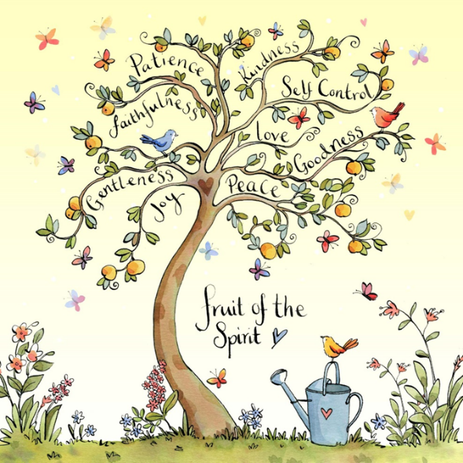
Love, Learn and Grow Together.

Our Vision
Commitment to promoting inclusivity, affirming diversity, embracing community and inspiring creativity, rooted in the words of St Paul who wrote, ‘The fruit of the Spirit is love, joy, peace, patience, kindness, goodness, faithfulness, gentleness and self-control’ (Galatians 5 v 22-23). These Christian values are fostered in the pupils and staff building an ethos where all can flourish.

Love: To develop collaborative opportunities with the children, parents, local church, communities and beyond.
Patience: To develop an atmosphere of mutual respect and teamwork that reflects our Christian ethos.
Faithfulness: To ensure that the Christian ethos permeates the life of our school.
Gentleness: To develop caring and safe learning environments that promote inclusivity and success.
Joy: To ensure children have a joy for learning through a dynamic and creative curriculum that stimulates all and allows children to flourish in a purposeful environment.
Peace: To develop respect for the community and wider ever changing world where diversity is celebrated.
Goodness: To maintain a family atmosphere and well-resourced classes that promote imagination and creativity so that all children can reach their full potential.
Self-control: To develop independent, resourceful and forward thinking learners.
Kindness: To foster a spirit of celebration of difference and an inclusive working environment where all children flourish.

The school’s vision and values statement reflects the school’s ambitions for all its pupils and have been developed with the whole community. It refers to the key requirements set out in the National Curriculum Inclusion Statement https://www.gov.uk/government/publications/national-curriculum-in-england-framework-for-key-stages-1-to-4/the-national-curriculum-in-england-framework-for-key-stages-1-to-4 for developing an inclusive curriculum: setting suitable learning challenges; responding to pupils’ diverse learning needs; overcoming potential barriers to learning and assessment, for individuals and groups of pupils.
The school is committed to addressing any actions which are identified to improve our inclusive practice.

School Context

School Context
Foston is a small village school with 40 pupils on role which, from Sept 2019, consists of three classes, Nursery, KS1 and KS2. 60% of the pupils that attend Foston Primary live out in the catchment area. 97.5% of the pupils are White British. The proportion of children receiving pupil premium funding is 7.5% and the percentage of children with Special Educational Needs (SEND) in main school is 24%. 42% of the KS2 children have SEND and an additional 25% are vulnerable. The percentage of children with an EHCP in main school is 10.3%. The school has successfully integrated two children with high need social, emotional and behavioural difficulties who were excluded from their previous schools. Foston school has been recognised by the local authority and allocated exceptional funding for the high standard of provision for SEND children. The school was also shortlisted for a national business education award in July 19 and received a commendation for SEND inclusion.
The school lowered its age range in 2016 to take 3 year olds into the early years room. We currently have 11 nursery children from 3 years old. This has had a positive impact on community relations and social and emotional provision for these children, alongside excellent transition into reception.
Foston has a high mobility rate, only 14% of KS2 pupils have been at Foston school since reception. The percentage of children who have been with us since the start of KS2 is 35%. Foston has historically received children in KS2 who are lower attaining. These children have made rapid progress with us but have sometimes not attained national averages. This has impacted on published data for our school due to small cohorts in each year group. School data shows good progress for the majority of our children and many made exceeding progress. Our EYFS KS1 data is significantly above national over the last 3 years.
Since the last inspection the governing body has now federated and is now Foston and Terrington Federation. Due to a long period of absence there has been much inconsistency in teaching in KS2. An experienced staff member has now been appointed as assistant head across the federation and teaches 0.5 in KS2 alongside another experienced teacher and an NQT teaches EYFS KS1. The school has a large staff due to the number of high need EHCP children.
Leadership of school is outstanding and leaders have an intricate knowledge of school and individual pupils ensuring through planning doing and reviewing in every aspect of children’s education all children flourish and make excellent progress towards and beyond their next steps. Teaching and learning, as a result is constantly moving forward through carefully planned CPD and tracked monitoring. The majority of teaching throughout school is now outstanding and outcomes reflect this, particularly in EYFS KS1. We share expertise in many areas with our cluster and beyond and have had significant input into leadership and management and EYFS. Over 80% of teaching staff are newly or recently qualified.
As a small school results can fluctuate due to the small numbers in each year group. The school also has a high number of children with high need social and emotional issues that can impact on overall outcomes. These needs are met exceptionally well through thrive and mental health interventions ensuring these children remain in education and make good progress.

School provision
Examples of reasonable adjustments the school makes as a matter of course
As a school we pride ourselves in adaptations to meet the needs of the wide range of children we have in school and also to develop our children as thoughtful, tolerant and understanding members of our school community. As a rural school our curriculum drivers of inclusivity, diversity, community and creativity lead the direction we take in meeting our equalities priorities in an individualised and tailored curriculum tailored to our school and it’s community.
Foston has an extremely high proportion of children with EHCPS, SEND needs and SEMH difficulties. Quality first teaching, Spld interventions, mental health support and adaptions for children with a huge range of SEND needs are outstanding.
Foston has a high number of children with significant medical needs or severe allergies. Adaptations are outlined in health care plans and shared with all staff to ensure safety and security are at the forefront of what we do.
Foston has little cultural or religious diversity being a small rural school so in order to ensure children have an excellent understanding of diversity of culture and religion we immerse our children in experiences that open their eyes to these differences.

Outcomes for pupils
Outcomes and progress for all children are excellent, in particular SEND children, many high need, children at risk of exclusion from previous schools, disadvantaged pupils or pupils with previous poor attendance make exceptional progress.

Equalities objectives

Our Equalities Objectives, based on needs analysis, for the period 2019-2023 are:
To promote spiritual, moral, social and cultural development through all appropriate curricular opportunities, with particular reference to issues of equality and diversity

To promote cultural development and understanding through a rich range of experiences both in and beyond the school

For further detail, please refer to the action plan at the end of this document.

Indicators of progress towards the objectives are reviewed on a cyclical basis and recorded in the action plan below
Roles and Responsibilities in Implementing the Single Equality Scheme and Equalities Objectives
The Head Teacher will:
- ensure that staff and parents are informed about the Single Equality Scheme and equality objectives;
- ensure that the scheme is implemented effectively;
- manage any day to day issues arising from the policy whether for pupils or for the school as an employer;
- ensure all hate incidents are recorded, appropriately responded to and reported to the Local Authority;
- ensure staff have access to training which helps to implement the scheme;
- liaise with external agencies regarding the policy so that the school’s actions are in line with the best advice available;
- monitor the scheme and report to the Governing Board at least annually, on the effectiveness of the policy and progress towards the equalities objectives;
- ensure that the SLT are kept up to date with any development affecting the policy/action plan arising from the scheme;
- provide appropriate support and monitoring for all pupils and specific and targeted pupils to whom the scheme and equality objectives has direct relevance, with assistance from relevant agencies.

The Governing Board will:
- ensure that the school complies with all relevant equalities legislation;
- designate a governor with specific responsibility for the Single Equality Scheme and equalities objectives;
- recommend the designated governor receive up to date training in all the equalities and SEND duties;
- support the Headteacher in implementing any actions necessary;
- publish equality objectives every four years
- evaluate the action plan annually
- publish information at least annually.

The Senior Leadership Team will:
- have general responsibility for supporting other staff in implementing this scheme;
- provide a lead in the dissemination of information relating to the scheme;
- identify good quality resources and CPD opportunities to support the scheme;
- with the Headteacher, provide advice/support in dealing with any incidents/issues;
- assist in implementing reviews of this scheme as detailed in the School Improvement Plan.

Parents/Carers will:
- have access to the scheme and equalities objectives;
- be encouraged to support the scheme;
- have the opportunity to contribute to the development of the scheme;
- have the right to a personalised approach to meeting additional needs and a right to have their views taken into account.
- have the right to be informed of any incident related to this scheme which could directly affect their child.

School Staff will:
- accept that this is a whole school issue and support the Single Equality Scheme and equalities objectives;
- be aware of the Single Equality Scheme and how it relates to them;
- be encouraged to express their views through a staff survey;
- make known any queries or training requirements
- know how to deal with incidents of concern, including bullying and how to identify and challenge bias and stereotyping;
- know procedures for reporting prejudice based and hate incidents;
- not discriminate on racial, disability or other grounds;
- keep themselves up to date with relevant legislation and attend training and information events organised by the school or LA;
- ensure that pupils from all groups are included in all activities and have full access to the curriculum;
- promote equality and diversity through teaching and through relations with pupils, staff, parents, and the wider community.

Pupils will:
- be encouraged to express their views and contribute where possible to the formulation of policies
- be made aware of any relevant part of the scheme, appropriate to age and ability;
- be expected to act in accordance with any relevant part of the scheme
- experience a curriculum and environment which is respectful of diversity and difference and prepares them well for life in a diverse society;
- understand the importance of reporting discriminatory bullying and racially motivated incidents;

Visitors and contractors are responsible for complying with the school’s Equality Scheme – non-compliance will be dealt with by the Headteacher.
Involvement Processes
Policies are vital to identify and consolidate thinking regarding appropriate provision for pupils, however, they are often viewed as an end, when they should be seen as a process - always evolving in response to changes and evidence from impact assessments. When developing this Equality Scheme and the equalities objectives, the school is clear that this is a process which must be informed by the involvement of all participants such as pupils, parents, school staff, governors and external agencies. This will ensure that the school gleans insights into the barriers faced by people from different social identity backgrounds and learns the best ways to overcome such barriers. This Scheme and equalities objectives will be informed, therefore, by:
- the views and aspirations of pupils themselves from different social identity backgrounds;
- the views and aspirations of parents of pupils from different social identity backgrounds;
- the views and aspirations of staff from different social identity backgrounds;
- the views and aspirations of members of the community and other agencies, including voluntary organisations, representing different social identity backgrounds;
- the priorities in the North Yorkshire Children and Young People’s Plan.

Mechanisms for involvement
At this school the following mechanisms will ensure the views of pupils inform the equality objectives and action plan:
- Discussion with the School council;;
- Individual interviews with pupils involved in incidents of a discriminatory nature or bullying related to discrimination;
- Individual interviews with pupils experiencing reasonable adjustments as required;
- Growing Up in North Yorkshire Pupil Survey

At this school the following mechanisms will ensure the views of staff inform the Equality
Scheme, objectives and action plan:
- Regular staff meetings with specific agenda items;
- Individual discussions with staff as a part of performance management
- Staff survey.
- Meetings with union representatives if required

At this school the following mechanisms will ensure the views of parents and the community inform the Equality Scheme, objectives and action plan:
- Welcoming parents and the community into school so that they feel part of the school community and therefore feel able to support school policy development where appropriate.
- Feedback through the Governing Board meetings;
- Feedback through parent questionnaires and individual meetings with parents
- Feedback from adults using the school beyond the school day

The school’s action plan will focus on developing the involvement of pupils, staff and parents from different social identity backgrounds over the four years (maximum) of this Scheme and the equalities objectives. We will consider varying the times, methods and the venues for this involvement to ensure the best possible attendance and ensure views can be heard. This way the school will learn what works and the involvement of pupils, staff and parents will improve and deepen over time.
Making it happen
Our Foston Primary School action plan, linked to this scheme can be found at the end of this document.
Reporting
This Scheme and equalities objectives will be reported on annually. Progress against the action plan will be evaluated and the impact of the action and activities assessed. Copies will be displayed in the school reception area and the school website and it will be referenced in school newsletters and in the school’s prospectus.
Publication
Equalities objectives will be available to anyone requesting a copy.
Information is published demonstrating how the school is complying with the Public Sector Equality Duty and the school’s equality objectives. The school updates its published information at least annually and publishes the equality objectives at least every four years.
Schools’ duties around accessibility for disabled pupils
If required, Foston Primary School will ensure thorough accessibility planning for disabled pupils as outlined in the guidance below;
4.28 Schools and LAs need to carry out accessibility planning for disabled pupils. These are the same duties as previously existed under the DDA and have been replicated in the Equality Act 2010.
4.29 Schools must implement accessibility plans which are aimed at:
• increasing the extent to which disabled pupils can participate in the curriculum;
• improving the physical environment of schools to enable disabled pupils to take better advantage of education, benefits, facilities and services provided; and
• improving the availability of accessible information to disabled pupils.
4.30 Schools will also need to have regard to the need to provide adequate resources for implementing plans and must regularly review them. An accessibility plan may be a freestanding document but may also be published as part of another document such as the School Improvement Plan.
4.31 OFSTED inspections may include a school’s accessibility plan as part of their review
See http://cyps.northyorks.gov.uk/equalities-and-diversity for an example of an accessibility plan.

This document relates to the The Equality Act 2010 and schools: Departmental advice for school leaders, school staff, governing bodies and local authorities May 2014, updated June 2018 DfE
https://www.gov.uk/government/publications/equality-act-2010-advice-for-schools
This is for:
- school leaders
- school staff
- governing bodies
It applies to:
- local-authority-maintained schools
- academies and free schools
- local authorities
- non-maintained special schools
- independent schools

5.16 Under specific duties set out in previous equality legislation, schools were required to produce equality schemes in relation to race, disability and gender. Under the specific duties there are no requirements to create equality schemes. But schools may choose to continue producing such a scheme, if it helps them to comply with the Equality Duty, and they can expand it to cover the additional protected characteristics

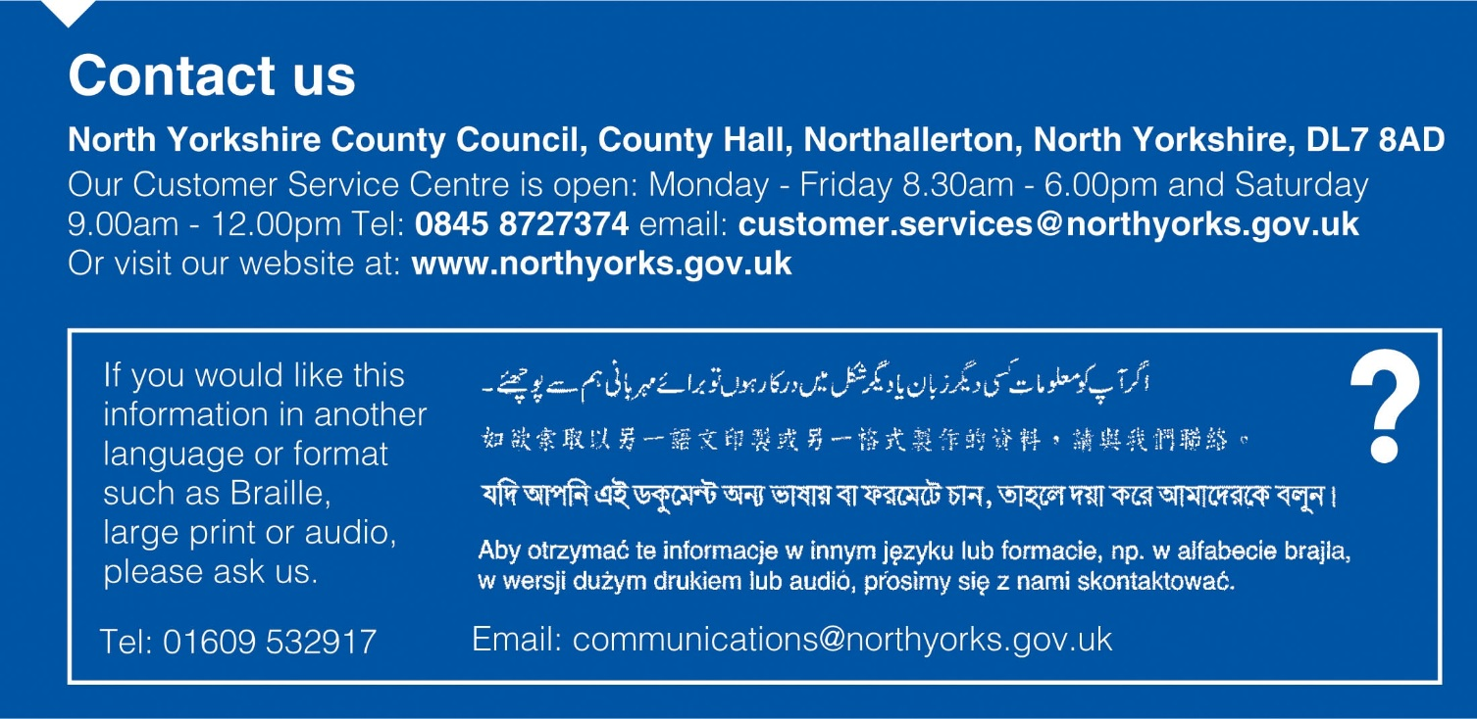

Appendix 1: Equality Legislation and Guidance

This equality scheme responds to the current equalities legislation.
- The Equality Act 2010 is the overarching legislation for all equality duties.

The act serves two main purposes:
- To harmonise discrimination law;
- To strengthen the law to support progress on equality.

The act supersedes or strengthens the following acts and regulations:
- The Equal Pay Act 1970
- The Sex Discrimination Act 1975
- The Race Relations Act 1976
- The Disability Discrimination Act 1995
- The Employment Equality (Religion & Belief and Sexual Orientation) Regulations 2003
- The Employment Equality (Age) Regulations 2006
- The Equality Act 2006 Part 2
- The Equality Act (Sexual Orientation) Regulations 2007
- The SEN Code of Practice 2001

Overview of previous equalities legislation which has been harmonised and strengthened by Equality Act 2010:
- Race Relations Act (RRA) 1976/2000
statutory positive duty to promote racial equality, promote good race relations and eliminate unlawful racial discrimination;
- Sex Discrimination Act (SDA) 1975 (and Regulations 1999), Gender Equality Duty 2007
statutory positive duty to promote gender equality and eliminate unlawful gender discrimination;
- Employment Equality (religion or belief) (sexual orientation) Regulations 2003 extended to education, Equality Act (Part 2) 2007
The Act sets out that is unlawful for schools to discriminate against a person:
a) in the terms on which it offers to admit him/her as a pupil:
b) by refusing to accept an application to admit him/her as a pupil, or
c) where he/she is a pupil of the establishment:
i) in the way in which it affords him/her access to any benefit, facility or service,
ii) by refusing him/her access to a benefit, facility or service,
iii) by excluding him/her from the establishment,
iv) by subjecting him/her to any other detriment.
- Disability Discrimination Act (DDA) 1995/2005
statutory positive duty to promote equality of opportunity for disabled people: pupils, staff, parents, carers and other people who use the school or may wish to, and eliminate unlawful discrimination;
- Education and Inspections Act 2006, duty to promote community cohesion.
By ‘community cohesion’ the school is endorsing and adopting the definition provided by Alan Johnson, 2006, as:
”working towards a society in which there is a common vision and sense of belonging by all communities; a society in which the diversity of people’s backgrounds and circumstances is appreciated and valued; a society in which similar life opportunities are available to all; and a society in which strong and positive relationships exist and continue to be developed in the workplace, in schools and in the wider community.”
Essential Further Guidance
DfE The Equality Act 2010 and schools: Departmental advice for school leaders, school staff, governing bodies and local authorities (May 2014, updated June 2018)
https://www.gov.uk/government/publications/equality-act-2010-advice-for-schools
Gender separation guidance, June 2018
https://www.gov.uk/government/publications/gender-separation-in-mixed-schools
Equality and Human Rights Commission Guidance for schools
http://www.equalityhumanrights.com/advice-and-guidance/education-providers-schools-guidance
SEND Code of Practice
https://www.gov.uk/government/publications/send-code-of-practice-0-to-25
North Yorkshire guidance on dealing with and reporting prejudice based incidents and hate crimes in schools and settings.
http://cyps.northyorks.gov.uk/equalities-and-diversity
Foston and Terrington Federation School Equality Action Plan
2019-2023
Governor with Responsibility for Single Equality Action Plan –
KEY ISSUE 1
To promote spiritual, moral, social and cultural development through all appropriate curricular opportunities, with particular reference to issues of equality and diversity.

Actions | Persons responsible for delivering the action | Start date | Finish date | Costs borne by the school | Monitoring Person and Method | Success criteria
- Continue to implement new curriculum and associated drivers in line with Christian Vision | SM KS | Sept 19 | Sept 20 | Resourcing £2000 | Govs | Vision realised through curriculum  Children have access to a range of equality / diversity opportunities which Aid their understanding
- Discrete PSHE sessions which are flexible to meet needs of children | IT | Sept 19 | Sept 20 | 0 | KS | All children have access to high quality PSHE  Children have a good understanding of equality and diversity
- Interventions to meet need of vulnerable children in terms of SEMH | KS SM | Sept 19 | Sept 20 | 0 | Govs | Vulnerable children have access to appropriate interventions to support SEMH

KEY ISSUE 2
To promote cultural development and understanding through a rich range of experiences both in and beyond the school.

Actions | Persons responsible for delivering the action | Start date | Finish date | Costs borne by the school | Monitoring Person and Method | Success criteria
- Interventions to meet need of vulnerable children in terms of SEMH and cultural capital | KS SM | Sept 19 | Sept 20 | 0 | Govs | Vulnerable children have access to appropriate interventions  Gap closes in terms of opportunities for cultural capital development
- Implement Government child passports to all parents and assess and deliver to vulnerable children | KS SM | Sept 19 | Sept 20 | 0 | Govs
.2

