Foston and Terrington CE Federation and Stillington Community Primary School
Behaviour and Discipline Policy

Foston and Terrington Behaviour and Discipline policy is informed by Christian values which underpin every aspect of our community’s life and work, including our curriculum. These values are rooted in the teaching of Jesus Christ. Central to our policy are St Paul, the apostles words, from a letter written in Galatians.

Stillington Community Primary Schools Behaviour Policy is informed by the shared values across the collaboration of schools.
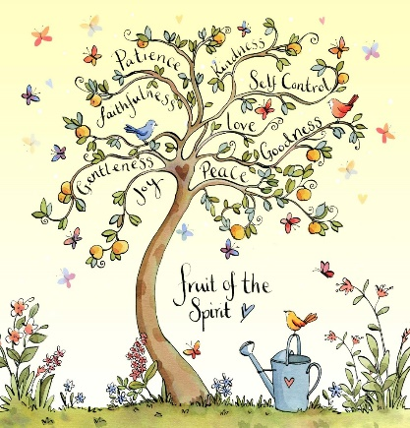

Love, Learn and Grow Together

Commitment to promoting inclusivity, affirming diversity, embracing community and inspiring creativity, rooted in the words of St Paul who wrote, ‘The fruit of the Spirit is love, joy, peace, patience, kindness, goodness, faithfulness, gentleness and self-control’ (Galatians 5 v 22-23). These Christian values are fostered in the pupils and staff building an ethos where all can flourish.

At Stillington Community Primary School our commitment to promoting inclusivity, affirming diversity, embracing community and inspiring creativity is rooted in the core values of love, joy, peace, patience, kindness, goodness, faithfulness, gentleness and self-control. These core values are fostered in the pupils and staff building an ethos where all can flourish.

This policy has been drawn up in consultation with pupils, staff, parents and governors and is in line with current legislation. The Governing Body recognises that it is their responsibility to ensure that, through the head teacher, good behaviour and discipline are maintained at Foston and Terrington Federation and Stillington Primary School.

Our Behaviour and Discipline Policy aims to:
- Foster a positive and compassionate environment in which children can flourish and reach their full potential
- Develop in our children a sense of self-discipline and acceptance of responsibility for their own actions
- Promote telling the truth, taking responsibility and accountability
- Encourage pupils to have respect for rules, laws and all forms of authority
- Create the conditions for an orderly community in which effective learning can take place, whereby there is mutual respect between all members
- Ensure that the school is a safe environment for all pupils and staff
- Develop relationships based on respect, generosity, integrity and trust between all members of the school community
- Raise awareness of desired behaviours by celebrating and rewarding occasions when our core values of love, joy, peace, patience, kindness, goodness, faithfulness, gentleness and self-control have been demonstrated

As a community we will:
- Build stronger relationships
- Experience what it means to live as a member of an open, generous and forgiving community
- Benefit from a calm and secure environment
- Be fully involved in regular reviews of our behaviour policy
- Model forgiveness and the possibility of restoration and a new beginning in our relationships
- Clearly convey behaviour expectations

We will promote Good Behaviour through:
- We will have reflection areas focussing on the core values in school
- Values Champion: Each week the staff / children will select a Values Champion from their class and they will be affirmed and praised during Friday’s collective worship
- Verbal praise and positive comments: Praise and positive comments etc. will be given readily. All staff will be encouraged to comment on good behaviour using our ‘Values language’ in order that children understand and relate their behaviour to our values
- Half termly sharing assembly to celebrate consistent good behaviour / work

All pupils will have the opportunity to regularly link their experience with our core values of love, joy, peace, patience, kindness, goodness, faithfulness, gentleness and self-control through our RE curriculum, assemblies, PSHE and citizenship curriculum and our restorative approaches.

Restorative Practice
This demands a positive policy encouraging appropriate attitudes through rewards and praise. We aim to prevent unacceptable behaviour rather than to react to it with restorative sanctions. The school uses restorative approaches to deal with any negative behaviour. This works by a neutral facilitator focusing attention on the harm that an incident has caused to others, by giving everyone the opportunity to answer the same questions and everyone given the same opportunity to speak. The controlled equality ensures the process is seen as fair. This encourages the truth and provides a safe environment so that responsibility can be acknowledged and genuine remorse felt. It is this feeling of remorse drawn out by the process that creates accountability.
By looking at what harm has been caused it brings the participants together to develop a solution. This allows them to take ownership of their solution making it much more likely to succeed. It not only allows the “harmer” to see the impact of their behaviour but also allows the "harmed" person the opportunity to see if they contributed to the conflict in any way by their own behaviour. Both participants are then able to agree their own joint contract of how they are going to treat each other in the future. This gives them a personal stake in the success of the contract. Through the use of restorative practices, participants:

Develop - truth telling skills, responsibility, accountability
Learn about - real impact of actions, consequences
Are able to - make amends, show remorse, change behaviour, agree a way forward

Inclusion
As a school, we understand that a child’s behaviour may be a reaction to personal circumstance, a diagnosed condition, or a specific learning need. We actively seek to understand and support each and every child through giving behavioural targets, working with families and involvement of outside agencies where appropriate.

Code of Conduct
Pupils are made aware of the school rules and are expected to adhere to them. Every new family receives a copy of our Code of Conduct. Parents are expected to discuss the importance of this with the child.

This means that we:
- Respect our self, each other, staff, property and our school
- Are proud of ourselves and our school and stand up for what we believe in
- Are friendly, kind, show consideration and be cooperative
- Show tolerance towards others, respecting their views
- Are honest, trusting and hard-working
- Are polite, well-mannered and well-behaved
- Take responsibility for our words, actions and how we make others feel (See Anti-Bullying policy)
- Make the most of our learning opportunities and do not disrupt others from learning
- Use equipment safely and carefully
- Care and share
- Move gently and quietly around the school
- Will be good ambassadors when representing the school

Rewards and Sanctions (appendix)

Rewards

A traffic light system will be used in each class:

Rainbow – prize
Purple – sticker / house point
Green – daily starting point
Amber – warning (5 mins play)
Red – warning (10mins play)

During Friday’s collective worship a certificate will be awarded to a child from each class.

A values champion – where teachers choose a child who has shown they are using our school values.
Each child will receive a certificate be able to sit on a chair for the remainder of the assembly.

Each class can have their own reward systems running alongside the whole school system. These will be determined by the children and the class teacher e.g. beads in a jar, golden time, prizes for individual achievement or effort etc.

House points will be rewarded for good behaviour / hard work and totalled with the collaboration schools. A termly celebration will be held for the winning house.

Sanctions (Also see appendix flow chart)

Low level behaviours | Mid-level behaviours | High level behaviours
Chatting to classmates during lesson input, quiet work, assembly etc. | Ignoring a staff member’s request | Persistent refusal to comply with a staff members request
Touching/playing with equipment at an inappropriate time | Hitting/pushing another pupil in response to being pushed first | Unprovoked violence towards anyone in school
Moving around the classroom at an inappropriate time | Calling another pupil names/shouting in response to provocation | Swearing
Pushing in front of peers in the line | Disrupting a lesson/game to the extent others cannot working/playing | Destruction or damage to property (schools or pupils)
Running in school | Deliberately misusing classroom equipment | Refusal to remove themselves to another classroom at a staff members request
Taking equipment from another pupil | Persistent misuse of playground equipment | Using racist or homophobic language or comments against disabled people
Calling another pupil a name | Persistent breach of playground rules
Not engaging with staff members attempts to resolve a
problem/argument between
pupils

Please also refer to the School Anti-Bullying Policy document, Equalities scheme and LEA Exclusion Policy documents.

Parents and pupils have been consulted and their views have been incorporated into the review of this policy.

In line with Equalities Act 2010

Policy Reviewed (Stillington): September 2020

Agreed by staff (Stillington): September 2020

Review Date: September 2021

Signed: Date:

Chair of Governors

APPENDICES:

Inclusion

Children who are unable to engage with normative disciplinary practices

Where children are unable to engage with our behaviour systems because of immaturity, for example caused by developmental trauma, alternative strategies need to be implemented. Other startegies recommended by outside agencies will be used in these cases, with an emphasis on nurture rather than reward, punishment or separation from the group. Removal or exclusion of any type simply reinforce the child’s perceptions of being unworthy and unlovable, and invoke shame, so the child should be brought closer to the teacher or key worker at times of stress rather than removed from them, so a ‘time in’ rather than ‘time out’. If he/she needs to be removed from a room or situation, this will have a positive emphasis and will focus on re-establishing a calm state and reconnecting with key adults. Engagement with external agencies will also be sought if not already involved

Internal Exclusion

Foston and Terrington |  | Stillington
Year Group | Class Sent To | Year Group | Class Sent To
Nursery / Reception | Class 2 | EYFS KS1 | KS2
Year 1 / 2 | Class 2 | KS2 | EYFS KS1
Year 3 / 4 | Class 1

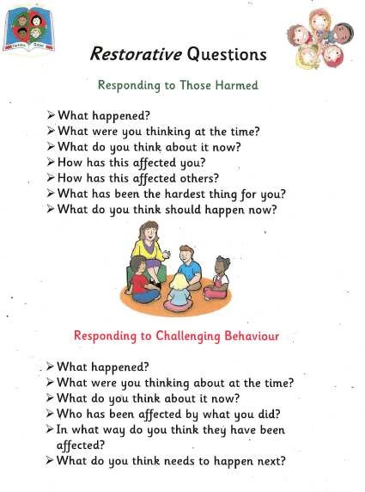

Restorative Practice
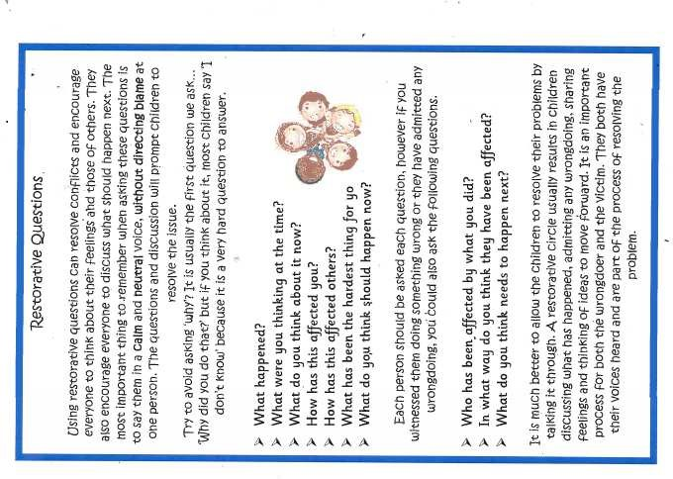

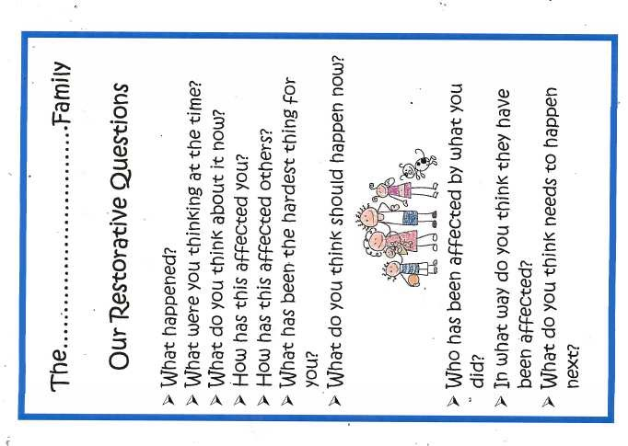

Behaviour Flow Chart

Low level behaviour

Verbal warning

Move name lose 5 mins playtime

Move again 15 mins playtime

If pupil loses a whole playtime it is recorded in their planner and behaviour log
If pupil loses 3+ playtimes in any half term class teacher will invite parents in to discuss behaviour and set up a behaviour plan including targets (NB Children can earn their 5 minutes sections back for good behaviour)

Mid-level behaviour

Verbal warning

Move to another class for the remainder of the lesson with their work and lose the subsequent playtime

Recorded in planner and behaviour log
If pupil loses 3+ playtimes in any half term HMc/LB will invite parents in to discuss behaviour and set up a behaviour plan including targets

High Level Behaviours

Immediately escorted to the HT/DHT/Senior Teacher

Pupil given time to calm down

HT/DHT/Senior Teacher will discuss the incident with the pupil using a restorative approach

Pupil will then work away from the other children for a fixed period of time as decided by HT/DHT/Senior Teacher

Incident recorded in planner and on behaviour log.

Parents informed and a behaviour plan reviewed or

written

Roles and Responsibilities

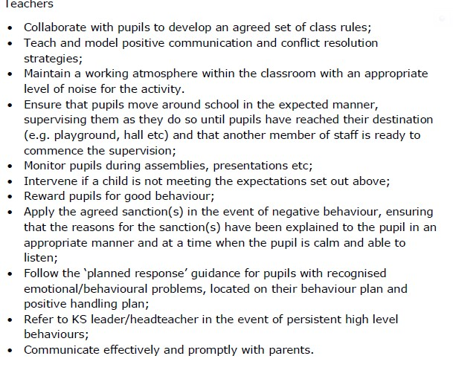

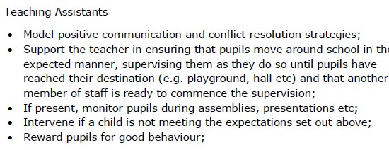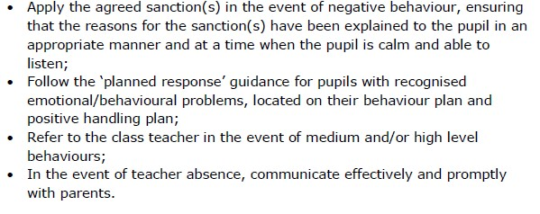

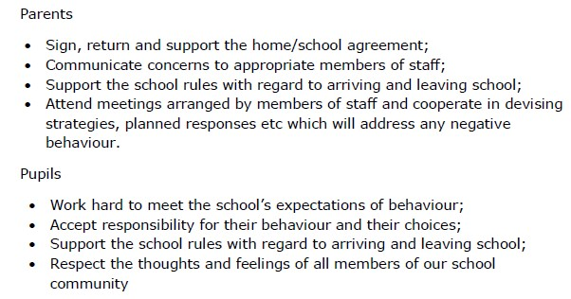

Checklist of routines

Have I taught the children a routine for:

[ ] coming into and leaving the classroom at the start and end of the day?

[ ] what to do during registration?

[ ] what to do if they are late?

[ ] showing that they are ready for learning at the start of the lesson?

[ ] distributing and collecting resources?

[ ] moving around the room?

[ ] understanding the levels of noise expected for different activities?

[ ] moving from one activity to another?

[ ] what to do when they are stuck, before asking an adult for help?

[ ] showing they need help from an adult?

[ ] getting an adult’s attention?

[ ] getting work marked?

[ ] what to do if they have finished an activity and have time to spare?

[ ] asking to leave the classroom?

[ ] asking to move to a quiet area if they are getting distracted or ‘ wound up’?

[ ] clearing up?

[ ] eating and drinking in the classroom?

[ ] leaving the classroom at break or lunchtime?

[ ] lining up at lunch time

[ ] lining up in alphabetical order

Other:

