Foston Primary School

Local Learning Area

Boundaries

The boundaries of the locality are shown on the attached map.

Thornton le Clay/Foston
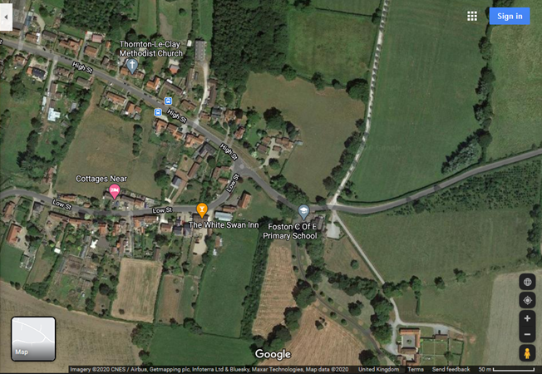

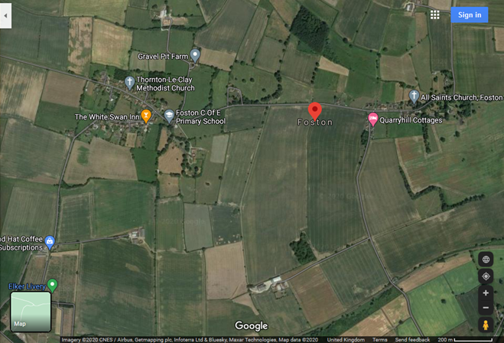

Terrington
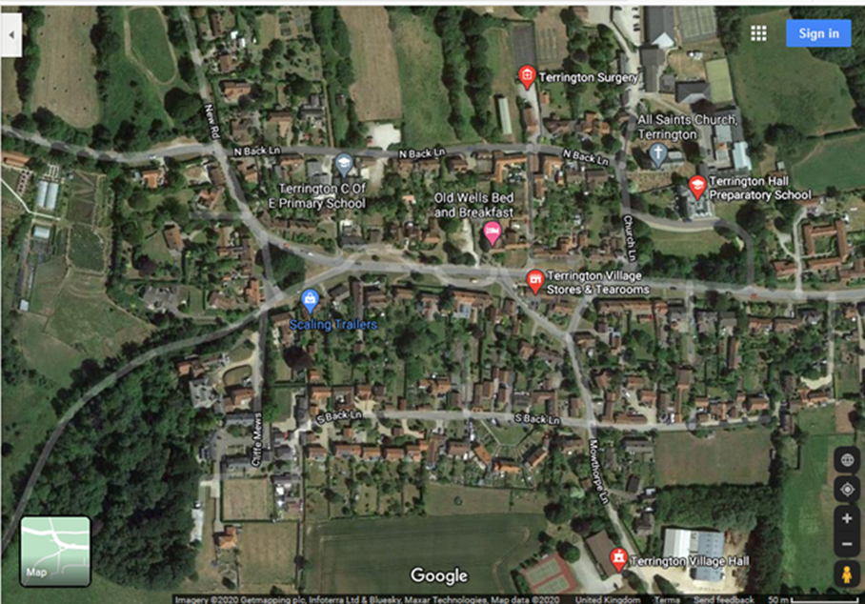

Stillington
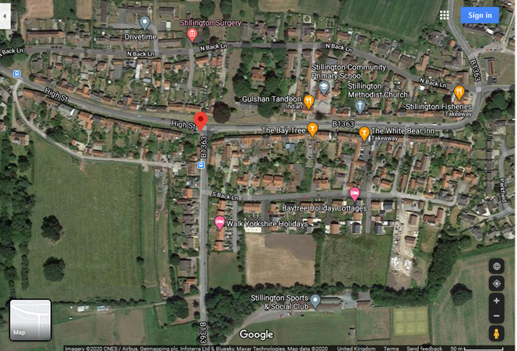

This area includes the following frequently used venues: e.g.
- Thornton le clay Methodist church
- All Saints Church Foston
- Thornton le Clay Village Hall
- Terrington Primary School
- Terrington Village Hall
- Terrington Prep School
- Stillington Primary School
- Stillington sports and social club
- St Nicholas' Church, Stillington
- Methodist church, Stillington

We use this extended area on a regular basis for a variety of learning activities, and visit leaders are allowed to operate in this area inputting visits on EVOLVE using the Local Learning Area option, provided they follow the below Operating Procedure.

(The below is in essence just a generic risk assessment for routine activities).

Operating Procedure for visits to the Local Learning Area

The following are potentially significant issues/hazards within our extended locality:
- Road traffic.
- Other people / members of the public / animals.
- Losing a pupil.
- Uneven surfaces and slips, trips, and falls.
- Weather conditions.
- Activity specific issues when doing environmental fieldwork (nettles, brambles, rubbish, etc).
- Travelling by bus to other schools.

These are managed by a combination of the following:
- The Head or EVC must give verbal approval before a group leaves. Not strictly necessary if you have clearly identified competent staff, and are confident in your operating procedure, and the fact that staff will follow it.
- Only staff judged competent to supervise groups in this environment are approved. A current list of approved staff is maintained by the EVC and office.
- The concept and Operating Procedure of the ‘Extended learning locality’ is explained to all new parents when their child joins the school.
- There will normally be a minimum of two adults.
- Staff are familiar with the area, including any ‘no go areas’, and have practiced appropriate group management techniques.
- Pupils have been trained and have practiced standard techniques for road crossings in a group.
- Where appropriate, pupils are fully briefed on what to do if they become separated from the group. (This needs a decision and will depend on the area you are in – return to school, wait where they are, go to x and ask for help, etc).
- All remotely supervised work in the extended learning locality is done in ‘buddy’ pairs as a minimum.
- Pupils’ clothing and footwear is checked for appropriateness prior to leaving school.
- Staff are aware of any relevant pupil medical information and ensure that any required medication is available.
- Staff will deposit in the office a list of all pupils and staff, a proposed route, and an estimated time of return. Consider adopting (or adapting) the ‘Signing-out sheet’ in EVOLVE Resources/Forms.
- A school mobile/walkie talkie is taken with each group and the office have a note of the number.
- Appropriate personal protective equipment is taken when needed (eg gloves, goggles) If you have a local issue, eg. with drug needles, etc, in any area, then you can mark that bit as no-go, or add here how you will educate the pupils to deal with it – it is their home after all, so they need to be able to cope with it!

